AT A GLANCE

P : PLANNING BEFORE DOING ANY WORK

R : RAW MATERIAL REQUIRED FOR THE WORK

O : ORGANIZATION OF WORK

J : JOINT BEFORE PUT TOGETHER IN THE WORK

E : ESTIMATION OF MATERIAL REQUIRED IN WORK

C : COSTING WORK

T : TECHNIQUES USED IN PERFORMANCE THE WORK

ABSTRACT

Universal Office is a software that supports several file types like doc, ppt, xls, txt, PDF, wmv, mov, dat as well as it supports many other services like -it can be used for browsing a site, chatting with friends in lan, Synchronize your data on web. running on MS Windows environment.

Multiple File Search and Replace is a piece of software which comes in handy when you need to replace words or phrases in file batches. This program can be used to replace, insert or delete the text of your choice in a large variety of file types: RTF, DOC, HTM, HTML, XML etc. The program has a nice and intuitive graphical user interface which makes it very easy to use. Basically, you need to select the folder (and subfolders) containing the text file you want to be modified, apply the file modification rule and that's all. Now, let's have a closer look at those modification rules. A rule can be created, saved and edited. When you create a rule, you need to specify the action (replace, insert, delete) and type of action, field identifiers (where applicable) and the text you want to replace, delete or insert in your files.

INDEX

Chapter No. | Name of the Topic | Page No
1 | Introduction
2 | Requirement Analysis
3 | System Requirement Specification
4 | Project Planning
5 | Detailed Design
6 | Project in Modular Format
7 | Implementation: GUI Snapshots
8 | System Testing
9 | Future Enhancement
10 | Conclusion
11 | References

Chapter No:1

INTRODUCTION

AIM :

To built Application an of universal office over the built-in Windows text editor, Notepad, Browser, Downloader is tabbed editing, which allows working with multiple open files.

BRIEF INTRODUCTION:

Universal Office is a software that supports several file types like doc, ppt, xls, txt, PDF, wmv, mov, dat as well as it supports many other services like -it can be used for browsing a site, chatting with friends in lan, Synchronize your data on web. Running on MS Windows environment. Based on the powerful editing component Universal Office is written in C# and uses pure Win32 API and STL which ensures a higher execution speed and smaller program size. By optimizing as many routines as possible without losing user friendliness, Universal Office is trying to reduce the world carbon dioxide emissions. When using less CPU power, the PC can throttle down and reduce power consumption, resulting in a greener environment.
Multiple File Search and Replace is a piece of software which comes in handy when you need to replace words or phrases in file batches. This program can be used to replace, insert or delete the text of your choice in a large variety of file types: RTF, DOC, HTM, HTML, XML etc. The program has a nice and intuitive graphical user interface which makes it very easy to use. Basically, you need to select the folder (and subfolders) containing the text file you want to be modified, apply the
file modification rule and that's all. Now, let's have a closer look at those modification rules. A rule can be created, saved and edited. When you create a rule, you need to specify the action (replace, insert, delete) and type of action, field identifiers (where applicable) and the text you want to replace, delete or insert in your files.

You can choose to rename words, phrases, special characters, but also text
found between beginning and end identifiers. This option proved to be highly
valuable when altering text in HTML files, such as links or text between
metatags. The results can be saved in the original file, files can be duplicated
containing the modifications or the modified files can be renamed. File
names cases can be set to small, 'as sentence' or large.

Some Features:
- File type recognition.
- Customizable screen display; display and other characteristics can be set for specific file types, both pre-fab and user determined
- Line breaks, tabs, and other special characters allowed in search and replace
- Multiple document interface (MDI) with tiling and minimizing supported
Keyboard remapping

LITERATURE SURVEY:

Text Editor, Word Processing Application and Calculation Application:
The problem is that there are a lot of different text files out there. Let's look just at the ones that Notepad supports.
- 8-bit ANSI (of which 7-bit ASCII is a subset). These have no BOM; they just dive right in with bytes of text. They are also probably the most common type of text file.
- UTF-8. These usually begin with a BOM but not always.
- Unicode big-endian (UTF-16BE). These usually begin with a BOM but not always.
- Unicode little-endian (UTF-16LE). These usually begin with a BOM but not always.
If a BOM is found, then life is easy, since the BOM tells you what encoding the file uses. The problem is when there is no BOM. Now you have to guess, and when you guess, you can guess wrong. For example, consider this file:

D0 AE:
Depending on which encoding you assume, you get very different results.
- If you assume 8-bit ANSI (with code page 1252), then the file consists of the two characters U+00D0 U+00AE, or "Ð®". Sure this looks strange, but maybe it's part of the word VATNIÐ® which might be the name of an Icelandic hotel.
- If you assume UTF-8, then the file consists of the single Cyrillic character U+042E, or "Ю".
- If you assume Unicode big-endian, then the file consists of the Korean Hangul syllable U+D0AE, or "킮".
- If you assume Unicode little-endian, then the file consists of the Korean Hangul syllable U+AED0, or "껐".
Okay, so this file can be interpreted in four different ways. Are you going to use the "try to guess" algorithm from IsTextUnicode? (Michael Kaplan has some thoughts on this subject.) If so, then you are right where Notepad is today. Notice that all four interpretations are linguistically plausible.
Some people might say that the rule should be "All files without a BOM are 8-bit ANSI." In that case, you're going to misinterpret all the files that use UTF-8 or UTF-16 and don't have a BOM. Note that the Unicode standard even advises against using a BOM for UTF-8, so you're already throwing out everybody who follows the recommendation.
Okay, given that the Unicode folks recommend against using a BOM for UTF-8, maybe your rule is "All files without a BOM are UTF-8." Well, that messes up all 8-bit ANSI files that use characters above 127.
Maybe you're willing to accept that ambiguity, and use the rule, "If the file looks like valid UTF-8, then use UTF-8; otherwise use 8-bit ANSI, but under no circumstances should you treat the file as UTF-16LE or UTF-16BE." In other words, "never auto-detect UTF-16". First, you still have ambiguous cases, like the file above, which could be either 8-bit ANSI or UTF-8. And second, you are going to be flat-out wrong when you run into a Unicode file that lacks a BOM, since you're going to misinterpret it as either UTF-8 or (more likely) 8-bit ANSI.
You might decide that programs that generate UTF-16 files without a BOM are broken, but that doesn't mean that they don't exist. For example,
cmd /u /c dir >results.txt
This generates a UTF-16LE file without a BOM. If you poke around your Windows directory, you'll probably find other Unicode files without a BOM. (For example, I found COM+.log.) These files still "worked" under the old IsTextUnicode algorithm, but now they are unreadable. Maybe you consider that an acceptable loss.
The point is that no matter how you decide to resolve the ambiguity, somebody will win and somebody else will lose. And then people can start experimenting with the "losers" to find one that makes your algorithm look stupid for choosing "incorrectly".
Literatur Survey On Internet Applications:

Problems with CSS rendering on IE: (Conditional statements not a fix)
IE renders my Wordpress based website just fine. By just fine I mean acceptable for now. The only problem is IE doesn't show the background or text for my homepage widget titles. For browsers like Firefox, Chrome, Safari etc. etc. I am using a red gradient background with white text and rounded corners which of course work fine. For IE I added a conditional statement to set the background of the widget title as a solid red color with no rounded corners. Unfortunately this did not solve the problem. The background still does not show up. The crazy thing is, when I open up the website in IE7 using Wine on my Mac, the widget title background shows up with the solid color...
As a second measure of testing I set the background as a solid color with no rounded corners on the main stylesheet to see if it would work that in IE.

Literatur Survey On pdf reading and writing tools:
We are receiving numerous reports that web users are experiencing problems accessing .pdf documents using various earlier versions of Adobe/Acrobat Reader software.
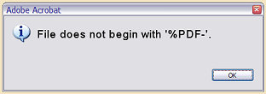
Frequently, older versions of the Adobe Reader will fail before beginning to display the .pdf documents embedded INSIDE the Microsoft Internet Explorer (MSIE) browser window (embedding is the reader software's default/preset behavior).
The vast majority of these problems disappear after upgrading your copy of Adobe/Acrobat Reader to the current version. (As of March 2011, the current version of Adobe Reader for Windows (XP, Vista, Windows 7) was version 10.0.1.)

Chapter No:2

REQUIREMENT ANALYSIS

Requirements Analysis in systems engineering and software engineering, encompasses those tasks that go into determining the needs or conditions to meet for a new or altered product, taking account of the possibly conflicting requirements of the various stakeholders, such as beneficiaries or users.
Requirements analysis is critical to the success of a development project. Requirements must be actionable, measurable, testable, related to identified business needs or opportunities, and defined to a level of detail sufficient for system design. Conceptually, requirements analysis includes three types of activity:
Eliciting requirements: The task of communicating with customers and users to determine what their requirements are. This is sometimes also called requirements gathering.
Analyzing requirements: Determining whether the stated requirements are unclear, incomplete, ambiguous, or contradictory, and then resolving these issues.
Recording requirements: Requirements might be documented in various forms, such as natural-language documents, use cases, user stories, or process specifications.

User Requirement:
An interactive GUI through which user can request for the desired data. Accordingly answers are given to queries requesting summarized data.

Front End used:
Microsoft Visual Studio dot Net is used as front end tool. The reason for selecting Visual Studio dot Net as front end tool is as follows:
.Net Framework 3.5:
Microsoft started the development on the .NET Framework in the late 1990s originally under the name of Next Generation Windows Services (NGWS). By late 2000 the first beta versions of .NET 1.0 were released. Version 3.0 of the .NET Framework is included with Windows Server 2008 and Windows Vista. Version 3.5 is included with Windows 7, and can also be installed on Windows XP and the Windows Server 2003 family of operating systems. On 12 April 2010, .NET Framework 4 was released alongside Visual Studio 2010.The .NET Framework family also includes two versions for mobile or embedded device use. A reduced version of the framework, the .NET Compact Framework, is available on Windows CE platforms, including Windows Mobile devices such as smartphones. Additionally, the .NET Micro Framework is targeted at severely resource-constrained devices.
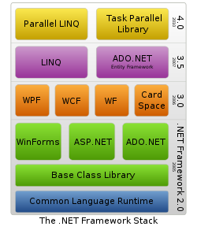

Design features:
- Interoperability:

Because computer systems commonly require interaction between newer and older applications, the .NET Framework provides means to access functionality implemented in programs that execute outside the .NET environment. Access to COM components is provided in the System.Runtime.InteropServices and System.EnterpriseServices namespaces of the framework; access to other functionality is provided using the P/Invoke feature.

- Common Language Runtime Engine:

The Common Language Runtime (CLR) is the execution engine of the .NET Framework. All .NET programs execute under the supervision of the CLR, guaranteeing certain properties and behaviors in the areas of memory management, security, and exception handling.

- Language Independence:

The .NET Framework introduces a Common Type System, or CTS. The CTS specification defines all possible datatypes and programming constructs supported by the CLR and how they may or may not interact with each other conforming to the Common Language Infrastructure (CLI) specification. Because of this feature, the .NET Framework supports the exchange of types and object instances between libraries and applications written using any conforming .NET language.

- Base Class Library:

The Base Class Library (BCL), part of the Framework Class Library (FCL), is a library of functionality available to all languages using the .NET Framework. The BCL provides classes that encapsulate a number of common functions, including file reading and writing, graphic rendering, database interaction, XML document manipulation, and so on.

- Simplified Deployment:

The .NET Framework includes design features and tools which help manage the installation of computer software to ensure it does not interfere with previously installed software, and it conforms to security requirements.
- Security
The design is meant to address some of the vulnerabilities, such as buffer overflows, which have been exploited by malicious software. Additionally, .NET provides a common security model for all applications.

- Portability

While Microsoft has never implemented the full framework on any system except Microsoft Windows, the framework is engineered to be platform agnostic,^{[5]} and cross-platform implementations are available for other operating systems (see Silverlight and the Alternative implementations section below). Microsoft submitted the specifications for the Common Language Infrastructure (which includes the core class libraries, Common Type System, and the Common Intermediate Language),^{[6][7][8]} the C# language,^{[9]} and the C++/CLI language^{[10]} to both ECMA and the ISO, making them available as open standards. This makes it possible for third parties to create compatible implementations of the framework and its languages on other platforms.
Because computer systems commonly require interaction between newer and older applications, the .NET Framework provides means to access functionality implemented in programs that execute outside the .NET environment. Access to COM components is provided in the System.Runtime.InteropServices and System.EnterpriseServices namespaces of the framework; access to other functionality is provided using the P/Invoke feature.

Features of Microsoft Visual Studio Dot NET:
- Visual Studio .Net has flexibility, allowing one or more language to interoperate to provide the solution. This Cross Language Compatibility allows us to do projects at faster rate.
- Visual Studio. Net has Common Language Runtime, which allows the entire component to converge into one intermediate format and then interact.
- Visual Studio. Net provides excellent security when an application is executed in the system
- Visual Studio.Net has flexibility, allowing us to configure the working environment to best suit our individual style. We can choose between a single and multiple document interfaces, and we can adjust the size and positioning of the various IDE elements.
- Visual Studio. Net has an Intelligent feature that makes the coding easy and also dynamic help provides very less coding time.
- The working environment in Visual Studio.Net is often referred to as Integrated Development Environment because it integrates many different functions such as design, editing, compiling and debugging within a common environment. In most traditional development tools, each has a separate program, each with its own interface.
- The Visual Studio.Net language is quite powerful – if we can imagine a programming task it can be accomplished using Visual Basic .Net.
- After creating a Visual Studio. Net application, if we want to distribute it to others we can freely distribute any application to anyone who uses Microsoft windows. We can distribute our applications on disk, on CDs, across networks, or over an intranet or the internet.
- Toolbars provide quick access to commonly used commands in the programming environment. We click a button on the toolbar once to carry out the action represented by that button. By default, the standard toolbar is
displayed when we start Visual Basic dot Net. Additional toolbars for editing, form design, and debugging can be toggled on or off from the toolbars command on the view menu.
- Many parts of Visual Studio are context sensitive. Context sensitive means we can get help on these parts directly without having to go through the help menu. For example, to get help on any keyword in the Visual Basic language, place the insertion point on that keyword in the code window and press F1.
- Visual Studio interprets our code as we enter it, catching and highlighting most syntax or spelling errors on the fly. It’s almost like having an expert watching over our shoulder as we enter our code.

Chapter No:3

SYSTEM REQUIREMENT SPECIFICATION

SYSTEM REQUIREMENT

Functional Requirements:
1. Requirements might be documented in various forms, such as natural language documents, use cases, user stories, or process specifications.
2. Attractive UI using C#.

Software and Hardware Requirements:
Software Requirements
- Operating System : Windows XP, Windows 2003/2008 server, Windows 7
- Software : .Net Framework 3.5
- Language : C#

Hardware Requirements:
    - HARD DISK : 4 GB
    - RAM : 512 MB
    - PROCESSOR : Pentium IV or Later

I/O DEVICES : Keyboard, Mouse

Chapter No:4

PROJECT PLANNING

Project Planning:
Project Process Model
The development model that we will be following for implementing the software is waterfall model

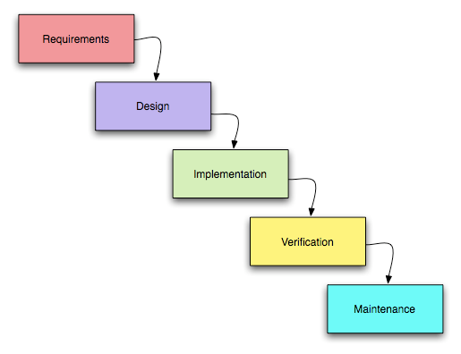
Fig 4.1: Project Process Model

Planning
The important task in creating a software product is extracting the requirements or requirements analysis. Customers typically have an abstract idea of what they want as an end result, but not what software should do. Incomplete, ambiguous, or even contradictory requirements are recognized by skilled and experienced software engineers at this point. Frequently demonstrating live code may help reduce the risk that the requirements are incorrect.

Once the general requirements are gleaned from the client, an analysis of the scope of the development should be determined and clearly stated. This is often called a scope document.
Certain functionality may be out of scope of the project as a function of cost or as a result of unclear requirements at the start of development. If the development is done externally, this document can be considered a legal document so that if there are ever disputes, any ambiguity of what was promised to the client can be clarified.

Design
Domain Analysis is often the first step in attempting to design a new piece of software, whether it be an addition to an existing software, a new application, a new subsystem or a whole new system. Assuming that the developers (including the analysts) are not sufficiently knowledgeable in the subject area of the new software, the first task is to investigate the so-called "domain" of the software. The more knowledgeable they are about the domain already, the less work required. Another objective of this work is to make the analysts, who will later try to elicit and gather the requirements from the area experts, speak with them in the domain's own terminology, facilitating a better understanding of what is being said by these experts. If the analyst does not use the proper terminology it is likely that they will not be taken seriously, thus this phase is an important prelude to extracting and gathering the requirements.

Input Design:
User type a keyword in the search textbox for finding corresponding files from peers. If user does not type any keyword, then a message is displayed indicating the user to type a keyword. After entering the keyword, the user must choose any of the options like documents, audio, video, image, code or software.
For example, when a user select document as the option then only the filetypes like .doc,.txt etc for the related keyword are retrieved. The keyword is searched in one peer and if it is matched then those files are displayed, otherwise the search is continued in another peer. If the file is available, it is displayed. Similarly, it searches all the peers connected with the networks and display the files that are found.

User can also enter the minimum and maximum size of the file. The results will be displayed with the File name, Location and Size of file. The locations show the different peers in the network.
User can select a searched file, and copy it and paste it to the local system. The user can also double click the file to view the selected file or open the containing folder of a searched file. User can also stop the search process while searching for a given keyword and clear the searched files from results panel by choosing the clearlist option from the search menu. The peerlist option in settings menu shows the list of peers that are active in the network. Users can also add or remove file extensions for various options like video, audio etc.

Output Design:

The output is designed to search and retrieve the documents, video, audio, image, software, code and all files/folders in peer to peer system in a network. Copy the searched file to local system and also view that files. The results are displayed based on the keyword, the option chose, and also upon the file size specified.

Code Design:

The code design should be such that with less amount of coding we can achieve more results. The speed of the system will be more if the coding is less. Whether the data in the system is usable and readable by the system is depending on the coding.
In the project, the coding is being done such that proper validations are made to get the perfect input. No error inputs are accepted. In addition care is taken such that the data integrity and referential integrity is not violated in the database.
In addition, coding is designed such that concurrency avoidance of accessing the database, limited user access to the table is made perfect.

Specification:
Specification is the task of precisely describing the software to be written, possibly in a rigorous way. In practice, most successful specifications are written to understand and fine-tune applications that were already well-developed, although safety-critical software systems are often carefully specified prior to application development. Specifications are most -

important for external interfaces that must remain stable. A good way to determine whether the specifications are sufficiently precise is to have a third party review the documents making sure that the requirements and Use Cases are logically sound.

Architecture:
The architecture of a software system or software architecture refers to an abstract representation of that system. Architecture is concerned with making sure the software system will meet the requirements of the product, as well as ensuring that future requirements can be addressed. The architecture step also addresses interfaces between the software system and other software products, as well as the underlying hardware or the host operating system.

Implementation:
Implementation is the part of the process where software engineers actually program the code for the project.
Testing:
Software testing is an integral and important part of the software development process. This part of the process ensures that bugs are recognized as early as possible.
Documenting:
Documenting the internal design of software for the purpose of future maintenance and enhancement is done throughout development. This may also include the authoring of an API, be it external or internal.

Deployment and maintenance:
Deployment starts after the code is appropriately tested, is approved for release and sold or otherwise distributed into a production environment.Software Training and Support is important because a large percentage software projects fail because the developers fail to realize that it doesn't matter how much time and planning a development team puts into creating software if nobody in an organization ends up using it. People are often resistant to change and avoid venturing into an unfamiliar area, so as a part of the deployment phase, it is very important to have training classes for new clients of your software.

Chapter No:5

DETAILED DESIGN

DESIGN:
Design is concerned with identifying software components and specifying relationships among components. It is used to provide software structure and also provides a blue print for the document phase. Modularity is one of the desirable properties of large systems. It implies that the system is divided into several parts, in such a manner, that the interaction between parts is minimal and clearly specified. Design will explain software components in detail. This will help the implementation of the system. Moreover, this will guide for further changes in the system to satisfy the future requirements.

Dataflow diagram:
Data flow diagram (DFD) is also called as “Bubble chart” is a graphical technique, which is used to represent information flow, and transformers those are applied when data moves from input to output.

DFD LEVEL0:

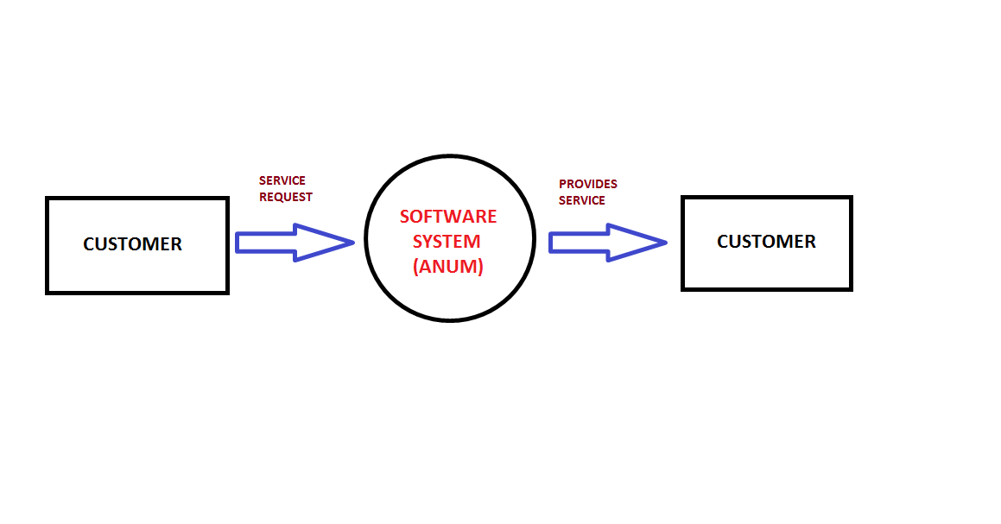
Fig:Level 0 (Customer sends the service request to the Software system.)

DFD LEVEL 1:
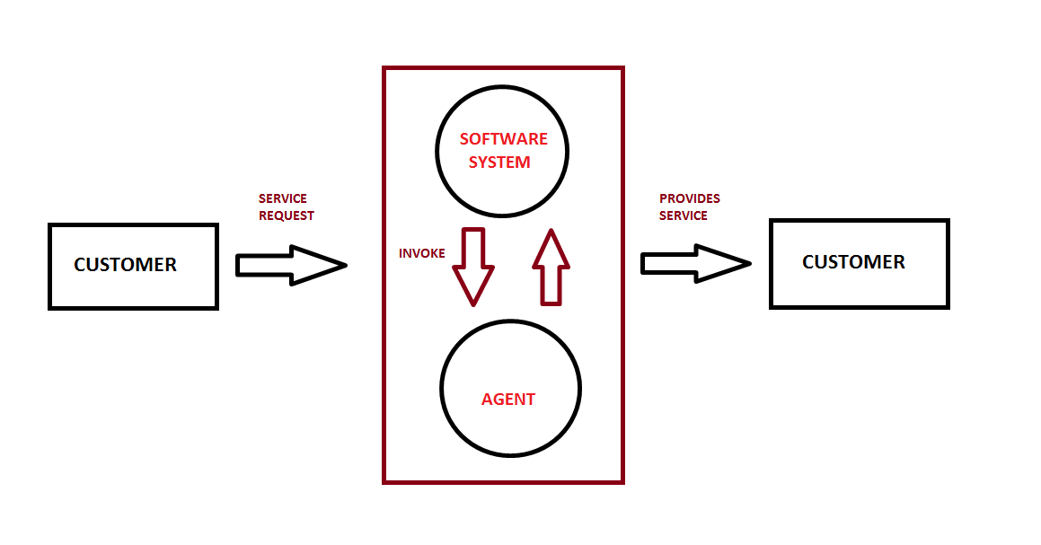
Fig:Level 1 (Customer sends the request to the software & then to the agent)

SEQUENCE DIAGRAM

A sequence diagram is a kind of interaction diagram in UML, which shows how processes operate one with another and in what order. It is a construct of a Message Sequence Chart. A sequence diagram shows, as parallel vertical lines ("lifelines"), different processes or objects that live simultaneously, and, as horizontal arrows, the messages exchanged between them, in the order in which they occur. This allows the specification of simple runtime scenarios in a graphical manner.

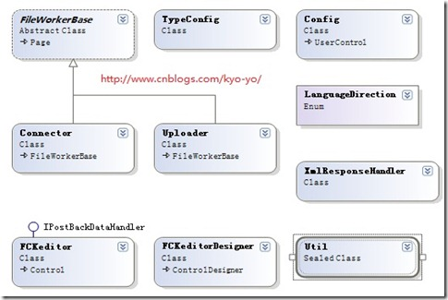

Fig : Sequence Diagram for Negotiation

ACTIVITY DIAGRAM

An activity diagram is a diagram that shows activities and actions to describe workflows. In the Unified Modeling Language an activity diagram represents the business and operational step-by-step workflows of components in a system. An activity diagram shows the overall flow of control.

CLASS DIAGRAM

Class Diagram is a type of static structure diagram that describes the structure of a system by showing the system's classes, their attributes, and the relationships between the classes.
Fig: Class Diagram:

Chapter No:6

PROJECT IN MODULAR FORMAT

PROJECT IN MODULAR FORMAT:

UNIVERSAL DOCUMENT:
There are many software packages to do the job of word processing. Some of them work in DOS environment. Example is WordStar, Word Perfect and Professional Write. But in these days working in WINDOWS is becoming more and more popular. So let us consider software for word processing which works in WINDOWS. Our choice is Universal-WORD because it is the most popular software in these days.
Universal -WORD is a part of the bigger package called Universal OFFICE, which can do much more than word processing. In fact when you open up Universal OFFICE you will find four main components in it. They are Universal -WORD (for word processing), UniversalCALCULATION (for spread sheet).
OBJECTIVES
After going through this lesson you should be in a position to
- start the UNIVERSAL-WORD package
- be familiar with the UNIVERSAL-WORD screen
- advantages and Features of Word Processing
- some common Word Processing Packages
- how to invoke Universal-Word
- learn the capabilities of Universal-Word
WHAT IS WORD-PROCESSING?
Word Processor is a Software package that enables you to create, edit, print and save documents for future retrieval and reference. Creating a document involves typing by using a keyboard and saving it. Editing a document involves correcting the spelling mistakes, if any, deleting or moving words sentences or paragraphs.
(a) Advantages of Word Processing
One of the main advantages of a word processor over a conventional typewriter is that a word processor enables you to make changes to a document without retyping the entire document.
(b) Features of Word Processing
Most Word Processor available today allows more than just creating and editing documents. They have wide range of other tools and functions, which are used in formatting the documents. The following are the main features of a Word Processor
- Text is typing into the computer, which allows alterations to be made easily.
- Words and sentences can be inserted, amended or deleted.
- Paragraphs or text can be copied /moved throughout the document.
- Margins and page length can be adjusted as desired.
- Spelling can be checked and modified through the spell check facility.
- Multiple document/files can be merged.
- Multiple copies of letters can be generated with different addresses through the mail-merge facility.
(c) Some Common Word Processing Packages
The followings are examples of some popular word processors available
- Softword
- WordStar
- Word perfect
- Microsoft word
IMPORTANT FEATURES OF UNIVERSAL-WORD
Universal-Word not only supports word processing features but also DTP features. Some of the important features of Universal-Word are listed below:
- Using word you can create the document and edit them later, as and when required, by adding more text, modifying the existing text, deleting/moving some part of it.
- Changing the size of the margins can reformat complete document or part of text.
- Font size and type of fonts can also be changed. Page numbers and Header and Footer can be included.
- Spelling can be checked and correction can be made automatically in the entire document. Word count and other statistics can be generated.
- Text can be formatted in columnar style as we see in the newspaper. Text boxes can be made.
- Tables can be made and included in the text.
- Word also allows the user to mix the graphical pictures with the text. Graphical pictures can either be created in word itself or can be imported from outside like from Clip Art Gallery.
- Word also provides the mail-merge facility.
- Word also has the facility of macros. Macros can be either attached to some function/special keys or to a tool bar or to a menu.
- It also provides online help of any option.

uNIVERSAL cALCI:
A UNIVERSAL CALCI is essentially a matrix of rows and columns. Consider a sheet of paper on which horizontal and vertical lines are drawn to yield a rectangular grid. The grid namely a cell, is the result of the intersection of a row with a column. Such a structure is called a UNIVERSAL CALCI.
As UNIVERSAL CALCI package contains electronic equivalent of a pen, an eraser and large sheet of paper with vertical and horizontal lines to give rows and columns. The cursor position uniquely shown in dark mode indicates where the pen is currently pointing. We can enter text or numbers at any position on the worksheet. We can enter a formula in a cell where we want to perform a calculation and results are to be displayed. A powerful recalculation facility jumps into action each time we update the cell contents with new data.
 Electronic spreadsheet
 Database management
 Generation of Charts.

Each workbook provides 3 worksheets with facility to increase the
number of sheets. Each sheet provides 256 columns and 65536 rows
to work with. Though the spreadsheet packages were originally
designed for accountants, they have become popular with almost
everyone working with figures. Sales executives, book-keepers,
officers, students, research scholars, investors bankers etc., almost any
one find some form of application for it.

UNIVERSAL PDF READER:

Although PDF documents are most often used for static content, they can also be used to represent user-fillable forms, much like HTML forms. PDF forms can be created by taking an existing PDF document and placing form fields on it using e.g. Adobe® Acrobat®. In many scenarios the resulting PDF forms are filled out by human users using a PDF viewing tool such as Adobe Acrobat. The actual data can be separated from the PDF that contains the representation using FDF or XFDF files, the latter being an XML format that contains the content of the form fields of a particular document. By using FDF or XFDF it is easy to programmatically fill out PDF forms in scenarios where the content is generated or queried from a database.
However, in certain scenarios it is required to incorporate the actual content into the PDF itself in order to have just one file that contains both content and representation. The small parser presented in this article helps to do just that, i.e. parse an existing PDF document containing form fields, get and set form field contents programmatically, and write the resulting PDF document back out.

Background
When We first started out trying to fill a PDF form programmatically, I had no idea what the PDF format looked like. So I just opened a PDF file with a text editor and discovered that the contents were actually human readable (or so it seemed). It was easy to identify the form fields and replace their content. Here's an excerpt from a PDF file that shows how a text field is represented:

2774 0 obj
<<
/Type /Annot
/Subtype /Widget
/Rect[ 27.09381 776.96008 194.09021 789.76807 ]
/F 4
/P 1996 0 R
/AP << /N 14 6 R >>
/DA (/Helv 10 Tf 0 g)
/T (Name)
/FT /Tx
/Ff 4194304
/DV (Smith)
/V (Smith)
>>
Endobj

Here, /T (Name) represents, not surprisingly, the name of the field you assign to it in the properties dialog of Acrobat. It's also easy to figure out that the "Smith" strings in parentheses represent the content of the field. /V stands for the actual value, while /DV represents the default value that the field content reverts to when the field is reset.
If you replace the string "Smith" by "Jones" you will find that the field content has not actually changed, but will change only after you click on the field in Acrobat. This is because Acrobat does not use the value of the form field for the visual representation, but "caches" the visual representation in an appearance stream object referenced from the /AP entry. Only after you click on the field will Acrobat regenerate the appearance stream and thus the visual representation. To work around this problem, you can try to find the appearance stream and change the string there as well.
But there are more problems. If you replace "Smith" by "Washington" Acrobat will report an error. This is because PDF is not in fact a text format but a binary format that contains an offset table with the byte offsets of the start of all objects.
If you change the offset of an object by extending an object earlier in the file but do not fix the offset table, the file gets corrupted. Usually Acrobat can fix minor errors in the offset table so you will usually still see something in Acrobat, but clearly this is not the right approach to filling form fields.
A workaround to this problem would be to always replace the exact same number of characters by truncating strings that are too long and padding with whitespace those that are too short. If you have control over the design of the PDF form you might choose as the initial content of each text field a fixed number of whitespace characters that definitely extend over the right edge of the field's box.
While these workarounds may be appropriate in certain situations, I found them not to be satisfying and wrote my own little PDF parser.

The PDF Parser:
The parser is not a full-fledged PDF parser but rather a small, one-class parser that can be dropped into any project where form field parsing is necessary instead of a whole library that adds a lot of overhead. Although the parser supports all types of PDF objects except for streams, it parses just the form fields of a PDF file by looking at the AcroForm dictionary.

If you need a full-fledged PDF parser you might want to look at the iText library which has been ported to several platforms including .NET.
The parser is designed as a straight-forward recursive descent parser. Since we are interested only in the form fields, the parser first parses the cross reference tables that contain the offsets of all objects and then finds the AcroForm dictionary that contains the identifiers of all form fields. Once we know the start and end offsets of all form fields, we can parse each form field object (which are a special form of dictionary object) in a recursive descent fashion. Summarizing, these are the steps to parse the whole PDF:
- Parse cross reference table(s) identifying byte offsets for all objects.
- Parse AcroForm dictionary object identifying form field object identifiers.
- Parse all form field objects in recursive descent fashion.
This leaves us with a list of (C#) objects whose contents can be programmatically queried and updated. In order to write a conformant PDF file, we make use of a feature of the PDF format that provides for easy extensibility of PDF documents. PDF objects provide a simple versioning mechanism that makes it possible to append newer versions of objects already contained in a PDF file to the file. We simply write out all field objects that have changed and add an updated cross reference table that links to the old cross reference table. This same mechanism is also used by
Acrobat itself when you change a form field and press the "Save" button. That's why PDF files keep getting bigger although you don't actually add any new content. Only when you do a "Save as" does Acrobat reorganize the PDF and eliminate duplicate object entries.

Using the code
The following example reads a PDF file, parses it, changes the value of a form field and writes an updated PDF file back out.

// read the file and parse it
PdfReader reader = new PdfReader(filename);

// change one text field
try
{
((PdfTXField)reader.FieldsByName["Name"]).Text = "Doe";
}
catch
{
}

// write the updated file back out
FileStream fileStream = new FileStream(newFilename, System.IO.FileMode.Create);
reader.WritePdf(fileStream);
fileStream.Close();

Points
- The parser can deal with almost all string representations the PDF Reference document provides for, i.e. literal string including escape sequences and hexadecimal strings with possibly missing digits. It can also parse Unicode (UTF-16) encoded text strings. Language detection is not supported, however. Strings are always written out in literal format.
- The parser supports all form field types except for signature fields. The supported types are Button (including Pushbutton, Checkbox, and Radio Button), Text, and Choice.
- The parser cannot currently deal with linearized PDF files, i.e. files that were saved with the option "optimized for fast web view" in Acrobat. Also, encrypted files cannot be parsed.
- For demo forms you might want to download the Adobe Acrobat Forms Samples package which includes a number of forms that exhibit most of the features of PDF forms.
- Adobe, Acrobat, and Acrobat Reader are either registered trademarks or trademarks of Adobe Systems Incorporated in the United States and/or other countries.

UNIVERSAL PDF CREATOR:

There are several ways to create PDFs. The hardest of them all is perhaps to create it on your own using C#. However, if you want to learn how to do so, you have to climb a steep learning curve. You can either read the 1300+ page specification document available free from Adobe's PDF Technology Center or use an open source library called iTextSharp. iTextSharp eases the learning curve a fair amount. But learning to use iTextSharp is itself non-trivial. The people behind iTextSharp have done a very nice job of putting together a set of tutorials. If you get through the tutorials, creating a PDF becomes somewhat easier. The tutorials, however, are based on .NET 1.x and cannot be used "out of the box" with .NET 2.0 without a fair amount of code rework.
This project contains the reworked .NET 2.0 code and a friendlier interface
- to get to the iTextSharp tutorials web site more directly
- to see the results of each chapter and example more easily (than on the iTextSharp web site)
- to access the Adobe reference resources a little more quickly

Background

Situation
After completing my XmlStore project (referenced below) I realized it had another useful application. To make a long story short, I needed a way to send tabular data (from DataGridViews and the like) to various friends. Some could deal with HTML, but not Excel. The reverse was true for some of the others. It turns out, the only format all of them can handle is PDF. So, I thought I could programmatically create PDFs from my DataGridViews, etc. Easier said than done!

Complication
It turned out there is no easy way to do this. Because I could not find a satisfactory solution to meet my needs, I decided to investigate the subject. The more I looked into it, the more intrigued I became. Then I stumbled upon iTextSharp. While it looked very promising, it was a challenge, and still is!!!.First because of the .NET version mismatch. Second, because the tutorials web site is out of sync with the downloaded version (as of Mar 14 or so). Third, it was just plain difficult to understand by reading alone.

Solution
Creating a PDF by reading a book is just as hard as creating a Windows application by reading a book. When it comes to things like understanding the quaint under-the-hood stuff of PDFs and such, people like me simply have to write code and try it ad nauseam until one has that epiphanic Aha! moment. So, I built this little application to test out much of the code in the iTextSharp Tutorials web site. Having gone through the tedious code cleanups, I am sharing it with people like you; it might get you up the learning curve a little faster.

Using the application
Simply selecting a chapter and an example will cause the PDF to be generated and displayed in the browser (using the Adobe Acrobat Reader, which one assumes you have). For example,
public bool Chap0501(string sFilePDF)
{
bool bRet = false;

Debug.WriteLine("Chapter 5 example 1: My First Table");

// step 1: creation of a document-object
Document document = new Document();

try
{
// step 2:
// we create a writer that listens to the document
// and directs a PDF-stream to a file
PdfWriter writer = PdfWriter.GetInstance(document,
new FileStream(sFilePDF, FileMode.Create));

// step 3: we open the document
document.Open();

// step 4: we create a table and add it to the document
Table aTable = new Table(2, 2); // 2 rows, 2 columns
aTable.AddCell("0.0");
aTable.AddCell("0.1");
aTable.AddCell("1.0");
aTable.AddCell("1.1");
document.Add(aTable);
bRet = true;
}
catch (DocumentException de)
{
this.Message = de.Message;
}
catch (IOException ioe)
{
this.Message = ioe.Message;
}

// step 5: we close the document
document.Close();

if (bRet)
this.Message = sFilePDF + " has been created";

return bRet;
}
This method along with all the others for chapters 1 through 6 are in the module called VVX_iTextSharp_Tutorials.cs; they are accessed via a class called iTextSharp_Tutorials in the VVX namespace.
The only way to learn is to mess around with the code. If you do, KEEP IN MIND, it is a very good idea to always get past the document.Close(); before you terminate a Debug session.

Code modules
Side benefits of the code for newbies (like myself): The project includes modules with reasonably documented and self-explantory code. With luck,
they may help you learn how to use a few features of the sub-systems employed.

VVX_iTextSharp_Tutorials.cs
VVX.iTextSharp is a class that contains about 3300+ lines of code for about 40 examples from the tutorials web site and reworked a bit to make them compatible with the above version of iTextSharp.DLL. The rework included the following:
- Updating names of methods, such as changing addCell to AddCell
- Updating names of enum values, such as changing RIGHT to ALIGN_RIGHT
- Adding a Message property so that I could display the status [of a call to create one of the example PDFs] in the UI's status bar as shown in the pictures above
- Adding helper methods, such as DoGetImageFile(...) and DoLocateImageFile(...) to help locate and load sample image files used in some of the tutorial examples. (These image files are in the Images folder.) I tend to prefix names of methods I created with a "Do" for two reasons -- first to distinguish them from methods that I did not create and second because they tend to show up together in the Intellisense pop-up
- Making sure there are explicit references to methods, types, properties, and such in the System.Drawing namespace to eliminate ambiguous references. Note: I also specifically commented out using System.Drawing; and recommend you do the same, as there are some methods and properties that appear to have slightly different meanings in the iTextSharp namespace
- Modifying the code for some of the examples, mainly to use the methods mentioned above, because both Adobe's PDF Reader and iTextSharp sometimes complain with unhelpful messages if the code fails to "properly" load and create images from these files. In virtually all such cases, I have wrapped my code and the original code in #if ... #else ... #endif

VVX_About.cs
VVX.About is a simple class that provides a "cheap", zero maintenance, "Help | About" message box. If you don't know how to access information in an assembly, it can show you one way of extracting some information from it.

VVX_FileDialog.cs
VVX.FileDialog is a class to access OpenFileDialog and SaveFileDialog a
little more efficiently. For example, the FileDialog.GetFilenameToOpen(...) method allows me to do something like this:
Code:
string filename = VVX.FileDialog.GetFilenameToOpen(VVX.FileDialog.FileType.XML);
if (filename.Length > 0)
{
this.DoGridPopulate(this.ctlTableDGV);
}
and
Collapse | Copy Code
string filename = VVX.FileDialog.GetFilenameToOpen(VVX.FileDialog.FileType.Image);
if (VVX.File.Exists(filename))
{
img = Image.GetInstance(filename);;
}
The methods simply takes care of setting up the filters, etc., before displaying the OpenFileDialog or SaveFileDialog to the user.

VVX_File.cs
VVX.File is a class to simplify access to a few File-related methods, such as Exists. Again, it is not rocket science, but I found it was hard to remember that you have to use the System.IO.FileInfo class to test for the existence of a file! I now can check a file with just this.

INTERNET BROWSER:

The browser control is a managed wrapper around the internet explorer control found in earlier versions of visual studio (SHDocVW.DLL) and it exposes some functionality that was not always easy to get at, while at the same time leaving out some functionality that would have made the control truly great to work with.
The goal of this article and accompanying sample application is to show working with the new WebBrowserControl in Visual Studio 2005 by cloneing many of the features in Internet Explorer 7. It is not meant to replace your existing browser or be a 100% complete implementation of a browser, The features implemented are to show examples of working with various properties and events of the control and some idea's on what to do to write your own complete browser application. Every feature is not fully error checked as this is meant to be a "starting point" for working with the control and every user interaction possibility has not been addressed. That said with minimal effort you could make this example a complete browser based application. You will find some tips in the comments for certain events and routines on how to improve or use that routine in your own applications as well as some "stubs" such as download manager, phishing filter, rss reader, Document Explorer, Image Grabber etc.
This example was put together with out referencing the Active X (SHDocVW.DLL) directly. That said, It again needs to be pointed out that the browser control is a managed wrapper around the internet explorer control found in earlier versions of visual studio (SHDocVW.DLL) and you may find a mix of the 2 will best suit your purposes.

Getting Started...
To make our example application one of the 1st things we are going to need is closable tabs, not wanting to re-invent the wheel a suitable tab control is found. The tabs used in this example were written by Eduardo Oliveira and can be found here. (Updated Tab Control Code provided by the author of the control. Thanks Eduardo).

Extending the browser control...
The browser control falls short on some basic functionality we will want to
use so we will need to extend the control, an example of this is the NewWindowevent..
New Window event standard with the control.
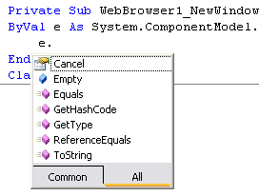
Now take a look at what we have with the extended browser.
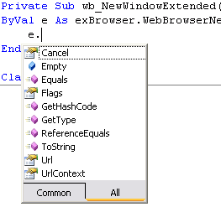
Please look at the extended browser control for how this was done, several MSDN articles were used in putting it together and you could certainly add a lot more.

Context Menus
One of the nicest features of the new control is the ability to override the built in context menu and create your own,not easily done in the past. In
this example we will use our own context menu, which will show you a bit about working with the loaded document directly.
To disable the built in menu set the web browser property IsWebBrowserContextMenuEnabledto false, then create your own context menu and set the browsers context menu to your new custom menu.
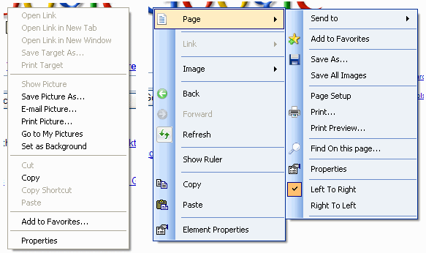
This is a pretty powerful tool especially when used with the controls document property as demonstrated in the example application.
* In the example application I do not check parent and children of the selected element, this would not be hard to implement if you choose to and would allow more accurate or robust options in the context menu.

JavaScript Document.External...
One of the most powerful features you can use, especially when creating intranet browser based applications is the javascriptwindow.external call in conjuction with your browser based application. You can build extremely powerful browser based applications using this functionality.
Our document might contain a link or onclick such as: window.external.AddSearchProvider
We can react to this call to window.external in whatever way we see fit, in this case we launch a form.
Collapse | Copy Code
Public Sub AddSearchProvider(ByVal value As String)
' See: http://www.opensearch.org/ for more information.
Dim ofrm As New frmAddSearchProvider
ofrm.strXML = value
ofrm.Show()
End Sub
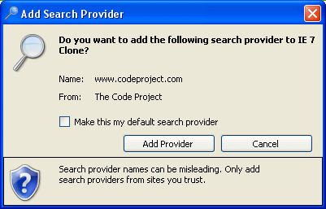
As you can see we are reacting to a call from the document.
window.external.AddSearchProvider/ Public Sub AddSearchProvider(ByVal value As String)
*Note - Make sure your routine signatures match as shown above in red.
Using this feature you can extend and add whatever type of feature you would want to provide...
Example:
Collapse | Copy Code
<a href="#" onClick="window.external.ShowCalc">ShowCalculator</a>

Public Sub ShowCalc()
Process.Start("Calc.exe")
End sub
This is also demostrated on the blocked site page to launch the settings form.
As you can see using this feature you can do just about anything you want to with the full power of a windows application.

Phishing Filters, Blocked Sites, Iterating the document etc...
The browser control exposes the loaded document making it easy to implement features such as a site blockers, phishing filters and simular types of features with a simple iteration through the documents elements allow you to check the document and perform actions based on it's contents.
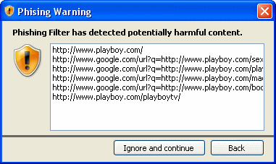
Collapse | Copy Code
Dim oEl As HtmlElement

For Each oElInwb.Document.All
'Do something based on the element.
Next
It should also be noted that the HtmlElementobject and the document itself has a rich set of functions and features to work with, you will see some of these in the example application such as: GetAttribute, GetElementFromPointetc...

UNIVERSAL DOWNLOADER:
It is an application written in C# that is almost a complete download manager. MyDownloader has many features to manage downloads:
- Segmented downloads from HTTP and FTP
  - With smart segments: when one segment ends, starts another segment to help to terminate another segment more fast
  - Automatic retry when a segment or download fails
- Allow downloads to be paused and resumed
- Video Downloads
  - Support to download videos from:
    - YouTube
    - Google Video
    - Break
    - PutFile
    - Meta Cafe
  - (NEW) Support to convert downloaded videos to MPEG, AVI and MP3 (using ffmpeg)
  - (NEW) Video file name suggestion based on video title
- Speed Limit — to avoid to use all your bandwidth
- Support for Auto-Downloads
  - (NEW) Limit the bandwidth at specific times
  - (NEW) Possibility to enable "Auto-downloads" at startup, allowing the downloads to start automaticaly at application startup
  - Download files only on allowed times
  - Limit the number of simultaneous downloads
  - When one download ends, starts another automatically
- Support for FTP site that requires authentication
- Support for Mirrors
- Download from HTTPS
- (NEW) Download from authenticated HTTP urls
- Notification download completion with sounds and XP balloon
- Anti-virus integration
- Batch downloads (enter a generic URL such as http://server/file(*).zip and MyDownloadergenerates a set of URLs with numbers or letters)
- (NEW) Move up / Move down button to change the order of download on download queue
- (NEW) Bug fixes and improvements
- (NEW) Web Spider (Web Crawler)
  - (NEW) Download all files from an specific page
  - (NEW) Download all images from an specific page
  - (NEW) Allow to filter URLs by extension or by name
- (NEW) Support to convert downloaded videos to MPEG, AVI and MP3 (using ffmpeg)
- (NEW) Video file name suggestion based on video title
- (NEW) Clipboard Monitor
- (NEW) Internet Explorer Integration
  - (NEW) Download links when they are clicked and the user is holding the ALT key
  - (NEW) When navigating tough an video site (YouTube, Google Video, etc), enable the video button to download the video with MyDownloader
  - (NEW) Button to launch MyDownloader
- (NEW) Import URLs from file
  - (NEW) From a local text file
  - (NEW) From a local html file

How a Segmented Download Works
Downloads can be segmented because both HTTP and FTP protocols allow the client to specify the start position of the stream. First, MyDownloader performs a request to the server to discover the file size. After that, MyDownloadercalculates the segment size as follows:
|
segment size = min( (file size / number of segments),
minimum allowed segment size )
With the segment size, MyDownloadercreates another request specifying the start position of the stream. In this way, we can have multi-requests for the same files running in parallel using multi-threading techniques. This technique speeds up the transfer rate even more if you are using mirrors.

Using the Code: MyDownloader API
To start a segmented download using the MyDownloaderAPI is very simple. Check the code below, extracted from the MyDownloadersource code. When the download is finished, an XP balloon is displayed near the windows clock:
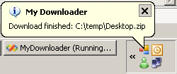
|
// starts to listen to the event 'DownloadEnded' from DownloadManager
DownloadManager.Instance.DownloadEnded +=

new EventHandler<DownloaderEventArgs>(Instance_DownloadEnded);

// indicates that download should start immediately
bool startNow = true;

Downloader download = DownloadManager.Instance.Add(
"http://jogos.download.uol.com.br/videos/pc/thewitcher12.wmv",
@"c:\temp\thewitcher12.wmv",
3, // Three segments

startNow // Start download now
);

void Instance_DownloadEnded(object sender, DownloaderEventArgs e)
{
if (Settings.Default.ShowBallon &&
AppManager.Instance.Application.NotifyIcon.Visible)
{
// Display the XP Balloon

}
finally
{
DownloadManager.Instance.OnEndAddBatchDownloads();
}
AppManager.Instance.Application.NotifyIcon.ShowBalloonTip(
Settings.Default.BallonTimeout,
AppManager.Instance.Application.MainForm.Text,
String.Format("Download finished: {0}", e.Downloader.LocalFile),
ToolTipIcon.Info);
}
}

Protocol Abstraction
On previous versions of MyDownloader, the protocols support was implemented by classes that inhererited from Downloader. This was because the previous version didn't support Mirrors, so at the time, a single download could only come from one source. But now, with Mirrors features, we can have one piece of a download coming from HTTP and another piece coming from an FTP server.
For that reason, I have refactored the code and now all supported protocols (HTTP, FTP, HTTPS) are implemented by classes that implement IProtocolProvider. The concrete instance of IProtocolProvider is created by ProtocolProviderFactory, protocols providers classes are implemented in a different class hierarchy from the Downloader class. This is done to address the restriction of using a single protocol for the download.
To make it easier to retrieve the correct IProtocolProvider, the ResourceLocation class has a factory method. This method is used by the Downloader class.
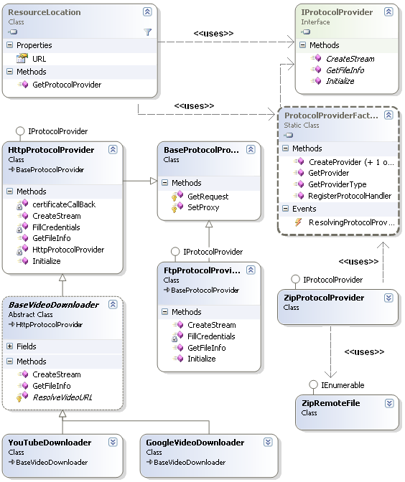

Plug-in Architecture
Many features from MyDownloaderare implemented using the concept of extensibility. Because the most important classes in MyDownloaderoffer a lot of events, extensions can listen to those events to change the application behavior. Another nice thing is that each extension has its own settings. Therefore the Options dialog needs to be created based on extensions. If you open Options at design time, you will only see an empty Panel.
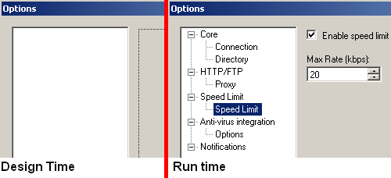
Below, you can see how we load settings from the extension to populate the tree view:
for (int i = 0; i < App.Instance.Extensions.Count; i++)
{
IExtension extension = App.Instance.Extensions[i];
IUIExtension uiExtension = extension.UIExtension;

Control[] options = uiExtension.CreateSettingsView();

TreeNode node = new TreeNode(extension.Name);
node.Tag = extension;

for (int j = 0; j < options.Length; j++)
{
TreeNode optioNd = new TreeNode(options[j].Text);
optioNd.Tag = options[j];
node.Nodes.Add(optioNd);
} treeOptions.Nodes.Add(node);
}
The DownloadManagerthat I showed in the beginning of this article also doesn't know anything about HTTP or FTP. DownloadManageraccepts protocols registered on ProtocolProviderFactory, and the HTTP and FTP protocols are registered by an extension. Check the HTTP/FTP download extension:
|
public class HttpFtpProtocolExtension: IExtension
{
#region IExtension Members

public string Name
{
get { return "HTTP/FTP"; }
}

public IUIExtension UIExtension
{
get { return new HttpFtpProtocolUIExtension(); }
}

public HttpFtpProtocolExtension()
{
ProtocolProviderFactory.RegisterProtocolHandler("http",
typeof(HttpProtocolProvider));
ProtocolProviderFactory.RegisterProtocolHandler("https",
typeof(HttpProtocolProvider));
ProtocolProviderFactory.RegisterProtocolHandler("ftp",
typeof(FtpProtocolProvider));
}

#endregion

}
When we think of an HTTP download, what are the settings that an HTTP downloader would require? Proxy is one of the answers. Many users are behind an HTTP proxy and connecting directly to an HTTP server is not allowed in most companies.
So, to expose the settings for our HttpFtpProtocolExtension, we need to create an IUIExtension and return it through UIExtension property of IExtension. On this class we implement the method CreateSettingsView, which returns all settings that will be displayed on Options dialog.
|
public class HttpFtpProtocolUIExtension : IUIExtension
{
public System.Windows.Forms.Control[] CreateSettingsView()
{
// create the Proxy user control an return it.

return new Control[] { new Proxy() };
}

public void PersistSettings(System.Windows.Forms.Control[] settingsView)
{
...
}

...
}
The HttpFtpProtocolUIExtensionclass provides a factory method named CreateSettingsView. This creates an array of Controls that are the visualization of the extension settings. The Options dialog uses this array to populate the TreeView of options and display the setting on the right panel.

Web Spider
Web Spider works over MyDownloaderAPI, the only secret on the spider is to parse the HTML pages using regular expressions. Below we can see a screenshot of Web Spider:
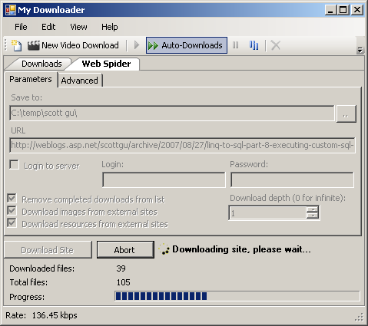
When an download of an file is complete (download state is changed to DownloaderState.Ended), the spider checks if it's an HTML document (comparing the mime type) and then lookup for all references such hyperlinks, images, frames and iframes. The following code is executed to add all page references to the download list:

|
...
if (download.RemoteFileInfo.MimeType.IndexOf("text/html",
StringComparison.OrdinalIgnoreCase) < 0)
{
return;
}
...
try
{
DownloadManager.Instance.OnBeginAddBatchDownloads();

using (Stream htmlStream = File.OpenRead(localFile))
{
using (HtmlParser parser = new HtmlParser(htmlStream))
{
AddUrls(parser.GetHrefs(context.BaseLocation), UrlType.Href);
AddUrls(parser.GetImages(context.BaseLocation), UrlType.Img);
AddUrls(parser.GetFrames(context.BaseLocation), UrlType.Frame);
AddUrls(parser.GetIFrames(context.BaseLocation), UrlType.IFrame);
}
}
}
finally
{
DownloadManager.Instance.OnEndAddBatchDownloads();
}

Video Downloads from YouTube, Google Video (and etc) with Conversion
Like many MyDownloader features, video downloads is just another extension. The secret is at VideoDownloadExtension and the "New Video Download" window. All URLs in MyDownloader are represented by the ResourceLocation class — this class has the method GetProtocolProvider which returns the apropriated instance of IProtocolProvider interface — the only thing that we need to do (at "New Video Download") is to force the correct protocol provider type by setting the property ProtocolProviderType of ResourceLocation.
Setting this property, when ResourceLocation class calls GetProtocolProvider, the created protocol provider will be the type stored in ProtocolProviderType, and not the provider registed on ProtocolProviderFactory. In this way we can replace the default protocol provider, and avoid that the HTML content be saved, and force to download the video from web site.
The first step is register the Video protocol providers on VideoDownloadExtension:
|
public VideoDownloadExtension()
{
handlers = new List<VideoDownloadHandler>();
handlers.Add(new VideoDownloadHandler(YouTubeDownloader.SiteName,
YouTubeDownloader.UrlPattern, typeof(YouTubeDownloader)));
handlers.Add(new VideoDownloadHandler(GoogleVideoDownloader.SiteName,
GoogleVideoDownloader.UrlPattern, typeof(GoogleVideoDownloader)));
// ... register other sites here ...

}
After registering, we need to discover which video handler we need to use and also, set the correct protocol provider on the ProtocolProviderType property of ResourceLocation. This is done at "New Video Download" window, check Below :
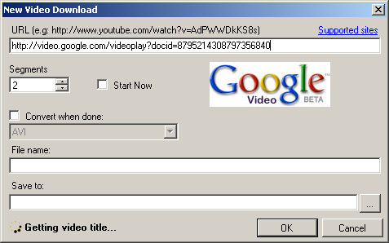
|
VideoDownloadExtension extension;
...
extension = (VideoDownloadExtension)App.Instance.GetExtensionByType(
typeof(VideoDownloadExtension));
...
handler = extension.GetHandlerByURL(txtURL.Text);
...
ResourceLocation rl = ResourceLocation.FromURL(txtURL.Text);
rl.ProtocolProviderType = handler.Type.AssemblyQualifiedName;
Basically, all video site handlers only need to parse the HTML page and return the URL of the FLV. This process have three main steps:
- Download the HTML page from the video site
- Parse the HTML to discover the video URL
- Return the video URL
All common things are on BaseVideoDownloader class. This class retrieves the HTML and starts to download the video. The inherited classes (YouTubeDownloader, GoogleVideoDownloader) are responsible to parse the HTML text and return the video URL to the base class. Below we can see how to get the URL from a FLV file on a YouTube page:
|
public class YouTubeDownloader: BaseVideoDownloader
{
public const string SiteName = "You Tube";

//http://www.youtube.com/watch?v=5zOevLN3Tic

public const string UrlPattern =
@"(?:[Yy][Oo][Uu][Tt][Uu]<bb />[Ee]\.[Cc][Oo][Mm]/watch\?v=)(\w[\w|-]*)"</bb />;

protected override ResourceLocation ResolveVideoURL(string url, string pageData,
out string videoTitle)
{
videoTitle = TextUtil.JustAfter(pageData,
"< meta name=\"title\" content=\"", "\">");

return ResourceLocation.FromURL(String.Format("{0}/get_video?video_id={1}&t={2}",
TextUtil.GetDomain(url), TextUtil.JustAfter(url, "v=", "&"),
TextUtil.JustAfter(pageData, "&t=", "&hl=")));
}
}
After downloadeding, the video can be converted to MPEG, AVI or MP3 (audio only), this process in done using an external open source tool: ffmpeg. This tool, which is a command line tool, is called by MyDownloaderwith the FLV filename and conversion arguments. If you want to see details about the arguments that were send to ffmpeg, I suggest you to download the code / demo project of this article.

Selecting Files inside a Remote ZIP File
This is another very cool feature of MyDownloder. Sometimes, you need to download an big ZIP file just because you want a single file inside the ZIP, on New Download window, if user checks the option "Choose files inside ZIP", MyDownloaderwill enumerate the files inside ZIP and allow user to select only that files that we want to download.
The feature is based on the article Extracting files from a remote ZIP archive and the updated version by Unruled Boy (see comments on the end of the article). Below we can the how New Download window displays the ZIP file and allow user to choose the files inside ZIP:

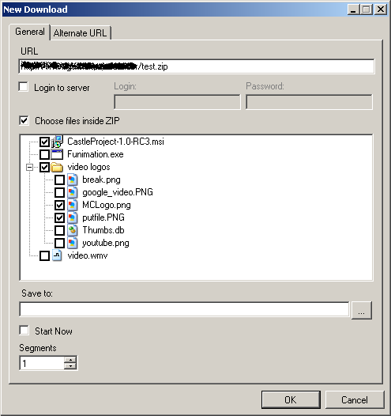

Auto-Downloads
The Auto-Downloads is activated (or deactivated) through the "two arrows" button in MyDownloadertoolbar. When this feature is enabled, MyDownloaderstarts to work as a batch downloader, accomplishing each download on download queue.
The maximum number of downloads is configured in the "Options" dialog. Another nice thing is that the user is able to choose at which times the "Auto-Downloads" will work and is also possible to limit the bandwidth usage at specific times. This is done easily by selecting the "time grid":
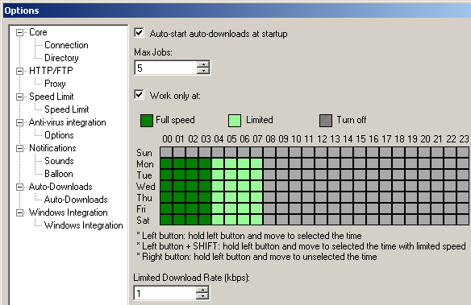
The Auto-Downloads, works using events (DownloadAdded, DownloadEnded) from DownloadManager. When some of these events were raised, the extension starts the download respecting the maximum number of simultaneous downloads:
|
using (DownloadManager.Instance.LockDownloadList(false))
{
int count = GetActiveJobsCount();
int maxJobs = Settings.Default.MaxJobs;
if (count < maxJobs)
{
for (int i = 0;
i < DownloadManager.Instance.Downloads.Count && (count < maxJobs);
i++)
{
if (DownloadManager.Instance.Downloads[i].State !=
DownloaderState.Ended &&

! DownloadManager.Instance.Downloads[i].IsWorking())
{
DownloadManager.Instance.Downloads[i].Start();
count ++;
}
}
}
}

Internet Explorer Integration
Browser integration is a critical feature for any download manager. This new version of MyDownloaderintroduces a very simple Internet Explorer (IE) integration. The IE integration is a IE toolbar, which is build on top of BandObjectLib, that has three main features:
- Shortcut button that be enabled when user is navigation on a video site that allow user to download the video
- Replace IE download window when user is holding Alt key
- Shortcut to lauchMyDownloader
Below we can see the IE displaying an empty page and perceive that the download button is disabled, the second image shows IE displaying a YouTube video and the download button became enabled:
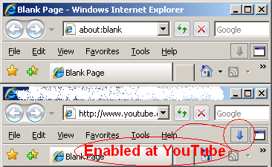
To enable the video download button, we need to listen to the AfterNavigate event from IE and then check if property LocationURL is an URL from a video site:
|
void AfterNavigate(object iDisp, ref object URL)
{
SHDocVw.WebBrowser IEDocument = GetIEDocument();

btnDownload.Enabled = videoSites.IsVideoSite(IEDocument.LocationURL);
}
To replace the IE download window (only when Alt is pressed), the FileDownload event is used:
|
void FileDownload(bool ActiveDocument, ref bool Cancel)
{
if (!ActiveDocument)
{
if ((Control.ModifierKeys & Keys.Alt) == Keys.Alt)
{
Cancel = true;

if ((DateTime.Now - lastDownload).TotalSeconds >= 1.9)
{
ThreadPool.QueueUserWorkItem(
delegate(object state)
{
DownloadURL(lastUrl);
});

lastDownload = DateTime.Now;
}
}
}
}

Import URLs from Files
Other new feature of MyDownloaderis "Import URLs from files" window, which allows the user to import the URLs from a text file or from an HTML file. The text files must to have one URL each line. For HTMLs, the URLs will be extracted using the same HTML parser used on Web Spider.
All URLs that were found in the file will be added to the download list. "Import URLs from files" window also have a shortcut to enable the "Auto-downloads", and to setup the maximum number of simultaneous downloads.
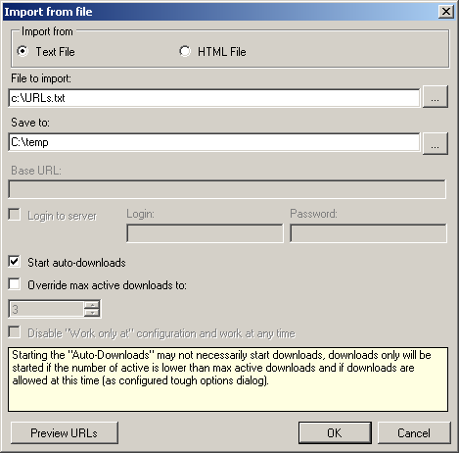

Future Ideas:
This kind of project is "infinite," so below I have listed some ideas for future implementations. As any open source project, it would be very nice if you wish to contribute.
- Add and remove segments while downloading
- Option to disable the speed limit while screen saver is running
- Integrate with FireFox and improve Internet Explorer integration
- Improve mirrors feature by choosing the fasters mirrors sites
- Support MMS protocol
- Create downloads category and allow downloads to be labeled
- XY graph to show the bandwidth usage

ADVANTAGES:

- Medium to heavy load capacity of table (aprox..30 kg safe load)
- Adjustable surface speed (0 to 2.4 m/min)
- Auto stop feature , to start and end process operation at precise positions.
- Multiple indexer positions (36 ) , enables to make staggered joints.
- Easy operation , as conveyor automatically stops as per indexer button position and next operation is started by merely pressing the inching switch.
- Compact, the entire drive assembly fitted below the table itself, and the controls are placed on the front at ergonomic positions.
- Low weight
- Low power consumption (50 watt)
- Easy to operate.
- Precise and noiseless in operation.

Chapter No:7

Implementation - GUI Snapshots

UNIVERSAL EDITOR:

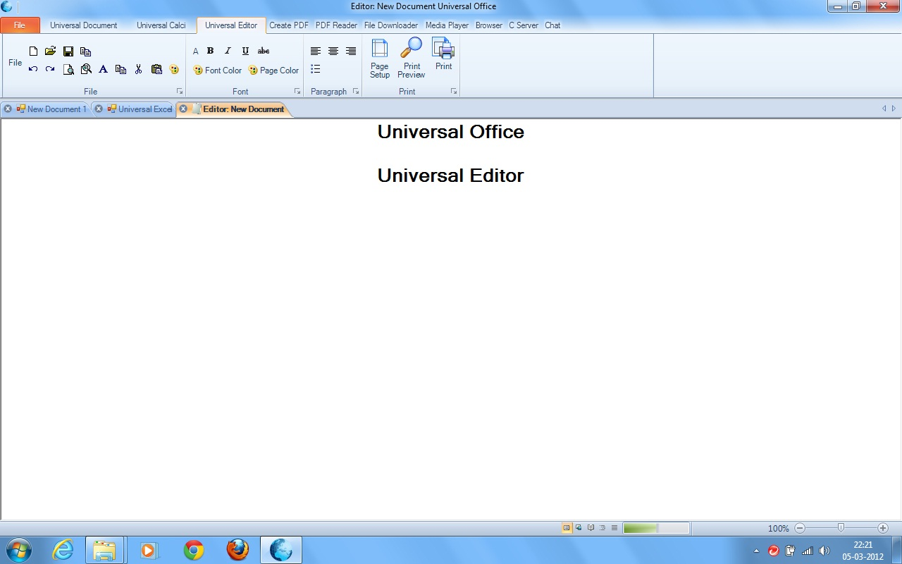

UNIVERSAL CALCI:

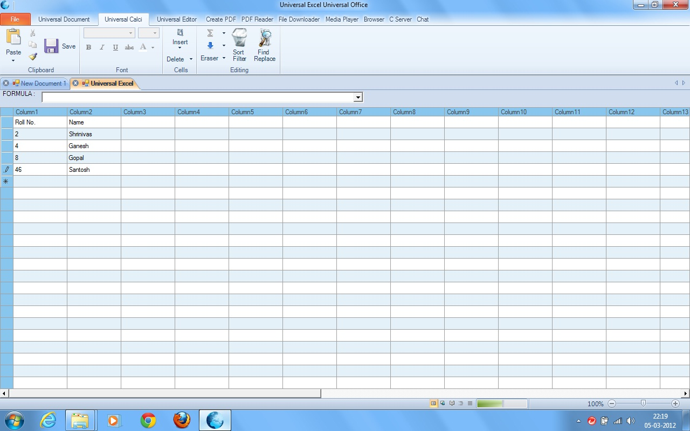

UNIVERSAL PDF READER:

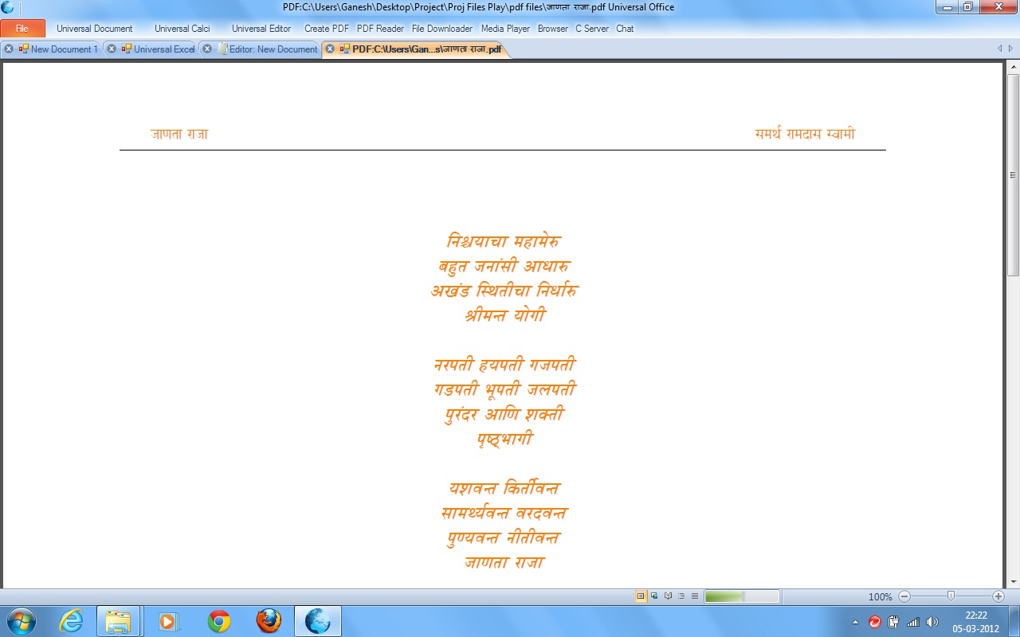

UNIVERSAL DOWNLOADER:

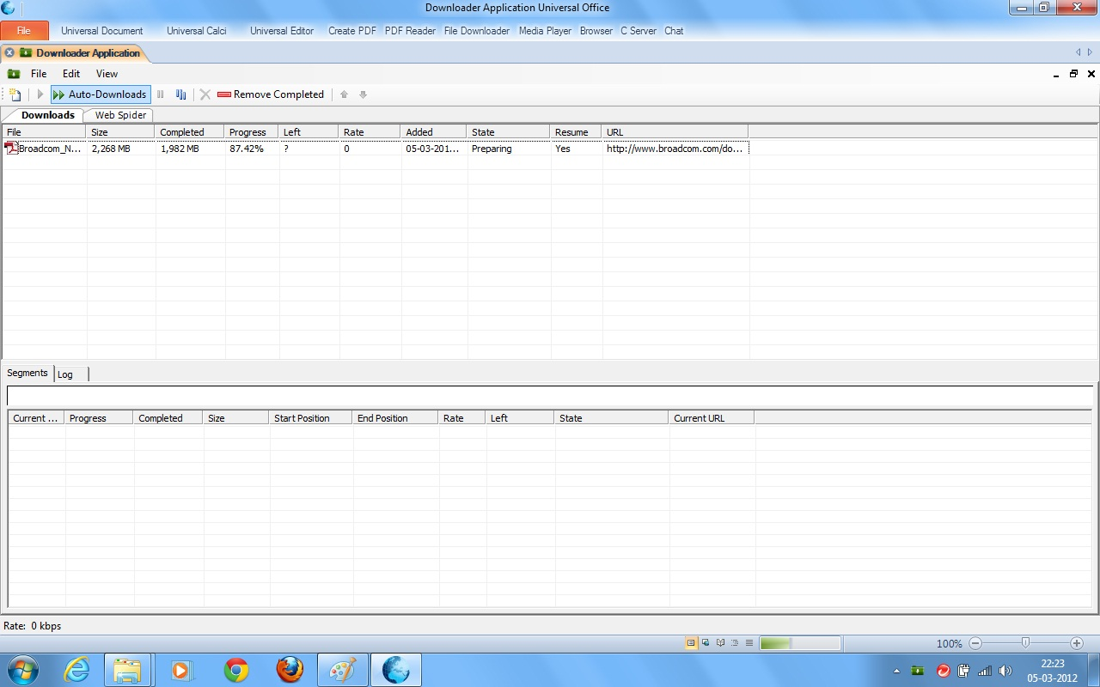

UNIVERSAL MEDIA PLAYER:

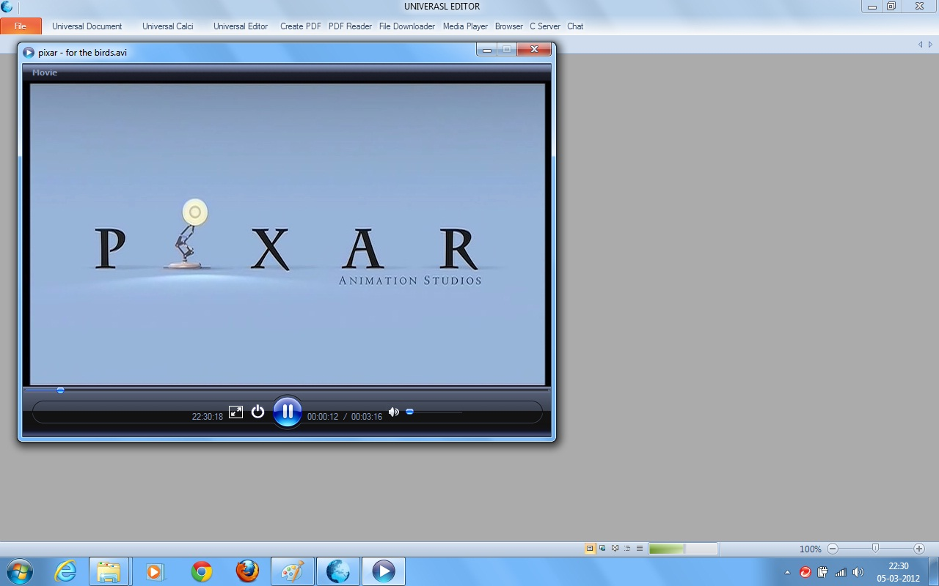

UNIVERSAL BROWSER:

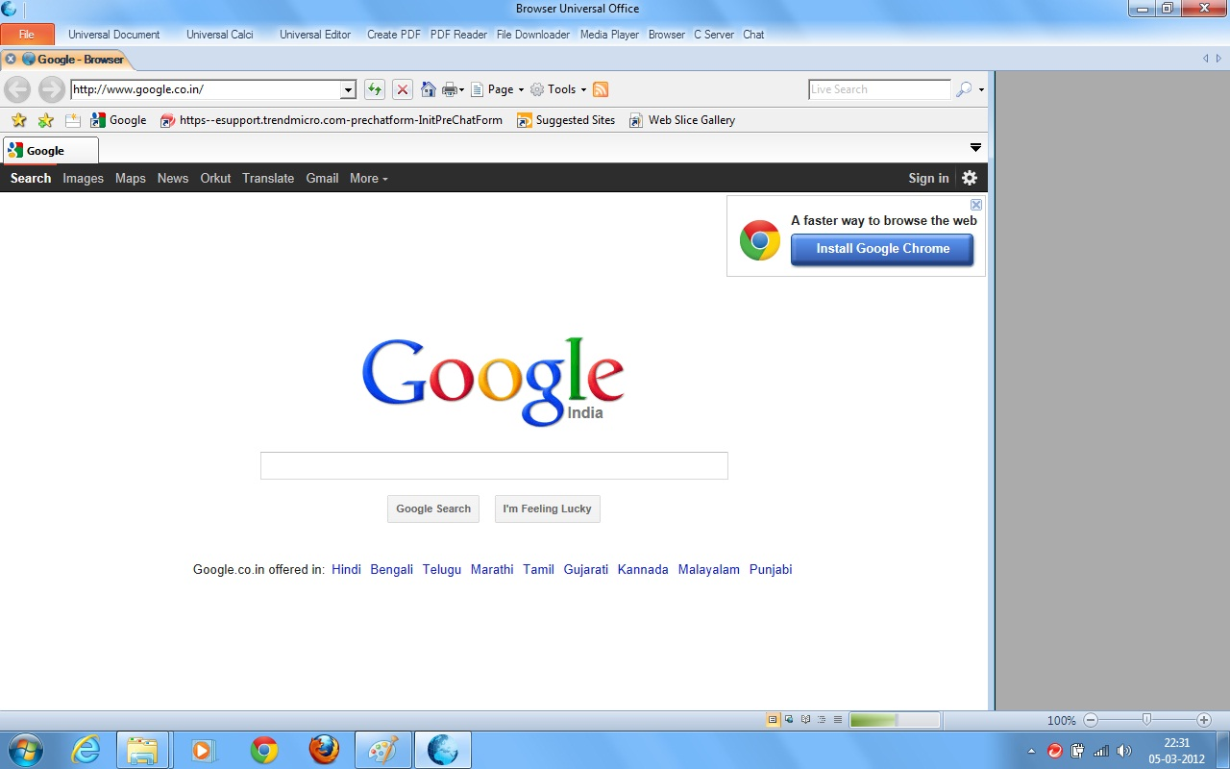

UNIVERSAL DOCUMENT:

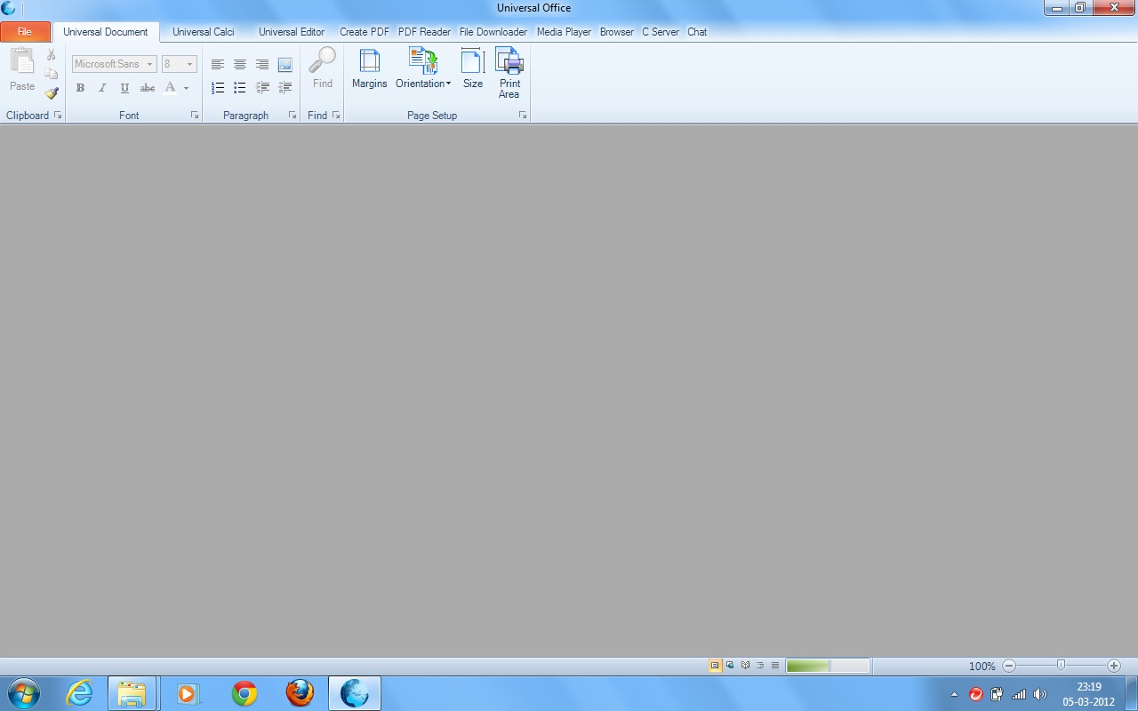

Chapter No:8

System Testing

System Testing

Testing is done for each module. After testing all the modules, the modules are integrated and testing of the final system is done with the test data, specially designed to show that the system will operate successfully in all its aspects. The procedural level testing is made first. By giving improper inputs, the errors occurred are noted and eliminated. Thus the system testing is a confirmation that everything is correct and an opportunity to show the user that the system works in a perfect way. The final step involves Validation testing, which determines whether the software, functions as the user expected. The end-user rather than the system developer conducts this test. Most software developers’ uses a process called “Alpha and Beta test” to uncover the errors that only the end user seems able to find.
This is the final step in system life cycle. Here we implement the tested error-free system into real-life environment and make necessary changes, which runs in an online fashion. Here system maintenance is done every month or year based on company policies, and is checked for errors like runtime errors, long run errors and other maintenances like table verification and reports.

Unit Testing:
Unit testing verification efforts on the smallest unit of software design, module. This is known as “Module Testing”. The modules are tested separately. This testing is carried out during programming stage itself. In these testing steps, each module is found to be working satisfactorily as regard to the expected output from the module.

Integration Testing:
Integration testing is a systematic technique for constructing tests to uncover error associated within the interface. In the project, all the modules are combined and then the entire programmed is tested as a whole. In the integration-testing step, all the errors uncovered are corrected for the next testing steps.

Validation Testing:
To uncover functional errors, that is, to check whether functional characteristics confirm to specification or not. Software validation is achieved through a series of black box tests that demonstrate conformity with requirement

Software Testing:
Software testing is any activity aimed at evaluating an attribute or capability of a program or system and determining that it meets its required results. Although crucial to software quality and widely deployed by programmers and testers, software testing still remains an art, due to limited understanding of the principles of software. The difficulty in software testing stems from the complexity of software: we can not completely test a program with moderate complexity. Testing is more than just debugging. The purpose of testing can be quality assurance, verification and validation, or reliability estimation. Testing can be used as a generic metric as well. Correctness testing and reliability testing are two major areas of testing. Software testing is a trade-off between budget, time and quality.
Regardless of the limitations, testing is an integral part in software development. It is broadly deployed in every phase in the software development cycle. Typically, more than 50% percent of the development
time is spent in testing.

Testing is usually performed for the following purposes:
- To improve quality.
- For Verification & Validation (V&V).
- For reliability estimation.
Black Box Testing:
The black-box approach is a testing method in which test data are derived from the specified functional requirements without regard to the final program structure. It is also termed data-driven, input/output driven or requirements-based testing. Because only the functionality of the software module is of concern, black-box testing also mainly refers to functional testing -- a testing method emphasized on executing the functions and examination of their input and output data. The tester treats the software under test as a black box -- only the inputs, outputs and specification are visible, and the functionality is determined by observing the outputs to corresponding inputs.
In testing, various inputs are exercised and the outputs are compared against specification to validate the correctness. All test cases are derived from the specification. No implementation details of the code are considered.
White Box Testing:
Contrary to black-box testing, software is viewed as a white-box, or glass-box in white-box testing, as the structure and flow of the software under test are visible to the tester. Testing plans are made according to the details of the software implementation, such as programming language, logic, and styles. Test cases are derived from the program structure. White-box testing is also called glass-box testing, logic-driven testing or design-based testing .
There are many techniques available in white-box testing, because the problem of intractability is eased by specific knowledge and attention on the structure of the software under test. The intention of exhausting some aspect of the software is still strong in white-box testing, and some degree of exhaustion can be achieved, such as executing each line of code at least once (statement coverage), traverse every branch statements (branch coverage), or cover all the possible combinations of true and false condition predicates (Multiple condition coverage).
Test Cases :-
Project name: Universal Office
Test case description: Test all the components of Auto Negotiation System and see if they are functioning according to requirements. Try every possible permutation and combination of input to check correct functioning. Mark fails if anomalies found.

What is a Cookie?
A cookie is some small information stored in a text file on the user’s hard drive by a web server. This information is later used by the web browser to retrieve information from that machine. Generally, a cookie contains personalized user data or information that is used to communicate between different web pages.

Why are Cookies used?
Cookies are nothing but the user’s identity and used to track where the user has navigated throughout the web site pages. The communication between the web browser and the web server is stateless. For example if you are accessing domain http://www.example.com/1.html then the web browser will simply query to example.com web server for the page 1.html. Next time if you type the page as http://www.example.com/2.html then the new request is sent to example.com web server for sending 2.html page and the web server won’t know anything about to whom the previous page 1.html served.
What if you want the previous history of this user communication with the web server? You need to maintain the user state and interaction between the web browser and the web server somewhere. This is where a cookie comes into picture. Cookies serve the purpose of maintaining user interactions with the web server.

Where are cookies stored?
When any web page application writes a cookie, it gets saved in a text file on user hard disk drive. The path where the cookies get stored depends on the browser. Different browsers store cookies at different locations. E.g. Internet explorer store cookies at “C:\Documents and Settings\Default User\Cookies”
Here the “Default User” can be replaced by the current user you logged in as. Like “Administrator”, or user name like “Vijay” etc.
The cookie path can be easily found by navigating through the browser options. In Mozilla Firefox browser you can even see the cookies in browser options itself. Open the Mozila browser, click on Tools->Options->Privacy and then “Show cookies” button.

Applications where cookies can be used:
- To implement a shopping cart: Cookies are used for maintaining online ordering system. Cookies remember what the user wants to buy. What if the user adds some products in his shopping cart and if due to some reason, the user doesn’t want to buy those products this time and closes the browser window? Well, when the next time the same user visits the purchase page, he can see all the products he added in the shopping cart in his last visit.
- Personalized sites: When a user visits certain pages he is generally asked about his preferences. User options are stored in a cookie and till the user is online, the pages are customizes as per his preferences.
- User tracking: To track the number of unique visitors online at a particular time.
- Marketing: Some companies use cookies to display advertisements on user machines. Cookies control these advertisements. When and which advertisement should be shown? What is the interest of the user? Which keywords does he search for on the site? All these things can be maintained using cookies.
- User sessions: Cookies can track user sessions to particular domain using user ID and password.

Test Cases:
- As a Cookie privacy policy make sure from your design documents that no personal or sensitive data is stored in the cookie.
- If you have no option than saving sensitive data in cookie make sure data stored in cookie is stored in encrypted format.
- Make sure that there is no overuse of cookies on your site under test. Overuse of cookies will annoy users if browser is prompting for cookies more often and this could result in loss of site traffic and eventually loss of business.
- Disable the cookies from your browser settings: If you are using cookies on your site, your sites major functionality will not work by disabling the cookies. Then try to access the web site under test. Navigate through the site. See if appropriate messages are displayed to the user like “For smooth functioning of this site make sure that cookies are enabled on your browser”. There should not be any page crash due to disabling the cookies. (Please make sure that you close all browsers, delete all previously written cookies before performing this test)
- Accepts/Reject some cookies: The best way to check web site functionality is to not accept all cookies. If you are writing 10 cookies in your web application, then randomly accept some cookies, say accept 5 and reject 5 cookies. For executing this test case you can set browser options to prompt whenever cookie is being written to disk. On this prompt window you can either accept or reject cookie. Try to access a major feature of web site. Check if pages crash or data becomes corrupt.
- Delete cookie: Allow site to write the cookies and then close all browsers and manually delete all cookies for web site under test. Access the web pages and check the behavior of the pages.
- Corrupt the cookies: Corrupting a cookie is easy. You know where cookies are stored. Manually edit the cookie in notepad and change the parameters to some vague values. You can alter the cookie content, the name of the cookie or expiry date of the cookie and check the site functionality. In some cases, corrupted cookies allow other domains to read the data inside them. This should not happen in case of your web site cookies. Note that the cookies written by one domain say rediff.com can’t be accessed by other domain say yahoo.com unless and until the cookies are corrupted and someone tries to hack the cookie data.
- Checking the deletion of cookies from your web application page: Sometimes a cookie written by a domain, say rediff.com may be deleted by the same domain but by a different page under that domain. This is the general case if you are testing some ‘action tracking’ web portal. Action tracking or purchase tracking pixel is placed on the action web page and when any action or purchase occurs by the user, the cookie written on the disk is deleted to avoid multiple action logging from same cookie. Check if reaching your action or purchase page deletes the cookie properly and no more invalid actions or purchases get logged from the same user.

Chapter No:9

Future Enhancement

Future Work
Planning for claim facility for sold Products.
Cooperative multi-agent decision analysis tools and negotiation protocols, on the hand, appear to map much better to the retail market model depicted. For example, multi attribute utility theory (MAUT) can help consumers make complex buying decisions takinginto account multiple factors including merchants’ unique added value (e.g., extended warranty options, delivery options, etc.). Constraintsatisfaction techniques can also help consumers make complex buying decisions and this paper explored using cooperativedistributed constraint satisfaction problem (DCSP) protocols to best support today’s (and likely tomorrow’s) retail market model . This analysis has guided the design of our new multi-agent system called Tete-a-Tete (T@T). T@T employs a combination of MAUT and DCSP techniques to mediate negotiations among consumer-owned shopping agents and retailer-owned sales agents. Once completed, we hope to show in our subsequent analysis of T@T that a bilateral, cooperative negotiation approach to retail electronic commerce allows merchants to tailor their offerings to each customer’s individual needs competitive online auctions.

Chapter No:10

CONCLUSION

CONCLUSION:

It gives us feeling of immense pleasure and happiness to have completed the project.

The project has been a great learning experience for all of us. As students, we had a wonderful experience of working actually in the computer lab with technical team of an industry. In the due course we also learnt in depth about many of developed softwares, which we had only read in the books. We also learnt advanced and highly accurate developing techniques. The project also taught us how to get the work done physically, economically and efficiently within the time limit.

In short the project has been the interesting part of whole Diploma course. We are confident what we have learnt during the project will help us to become more successful Computer engineers for the year to come and we will be able to get glory for our institute and our professors.

Chapter No:11

REFERENCES

REFERENCES:

Sites:
- http://msdn.microsoft.com/en-us/library
- http://msdn.microsoft.com/en-us/library/aa289518(v=vs.71).aspx

Books:
- Professional Asp.net
-by Wrox
- Asp.net in 21 days
-by Sams
- C#
-by Murchas
- Begineers Guide of C#
-by Balaguruswami

